Jimin Song

CS 46B LAB 2 Code / Lab 2 Report

1. What source code elements did Eclipse automatically create?

Public class Vehicle {}

1. Describe in words how Eclipse indicates that you have a compiler error.

IntelliJ shows red dot next to the wrong statement

1. What pops up? (Don’t type in the exact words; just briefly explain what the words tell you

Basically, it shows that our syntax is wrong and has to be edited in right syntax.

1. There is no constructor code in Vehicle.java. If you added the following to Vehicle, would you get a compiler error? Why or why not? (Don’t actually type in the code, just think about it). public static void main (String[] args) { Vehicle v = new Vehicle(); }

Yes, it will compile but it will return no results because vehicle class has implicit constructor.

1. “I/we were right about the compiler error.”
2. Describe what you see, or insert a screenshot into your report.

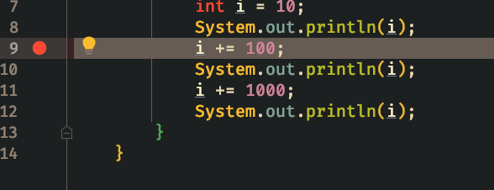

1. What happens?

Int i =10

1. Now what is i?

I = 110

1. In your report, write “I understand that it is my responsibility to get familiar with more features of Eclipse.

“I understand that it is my responsibility to get familiar with more features of Eclipse.”

1. In your report, write “Created 2 more classes”.

“Created 2 more classes”.

1. Write “UnmannedVehicle error = and the error message.

“UnmannedVehicle error = there is no default construction available in ‘transport in Vehicle’ “and the error message.”

1. Write a simple explanation.

I forgot to comment out closing bracket of Vehicle constructor

1. Write “Explicit UnmannedVehicle constructor => compiler errors” or “Explicit UnmannedVehicle constructor => no compiler errors”. Also explain why you saw what you saw.

Explicit UnmannedVehicle constructor => compiler errors”. The ctor requires the user of “super” instead of the explicit Vehicles ctor

1. If yes, write “UnmannedVehicle ctor: 1st line ok”; if no, write “UnmannedVehicle ctor: 1st line not ok”.

“UnmannedVehicle ctor: 1st line not ok”.

1. Write “The order will be:” and the three lines in expected order.

The order will be:

Vehicle ctor

Unmanned Vehicle ctor

Mars rover ctor

1. Paste the output into your report.

Vehicle ctor

Unmanned vehicle ctor

Mars rover ctor

1. Is a Mars Rover expensive? Should you try to save it?

Yes, it is expensive, and yes we should try to save it.

1. Paste the output.

“No more power”

1. Paste the output. Is Rover likely to fall off a cliff before it runs out of power? Are you surprised by this result?

Number times the rover fell: 0

The rover is not likely to fall off the cliff before it runs out of power. No I am not surprised by this result because with probability, the rover has 50% chance to go backwards or forwards. Over time, the average will be where the rover initially starts, so it will remain close to the starting position after moving n number of times.